Splatter Art Supply List

- A Silhouette to trace
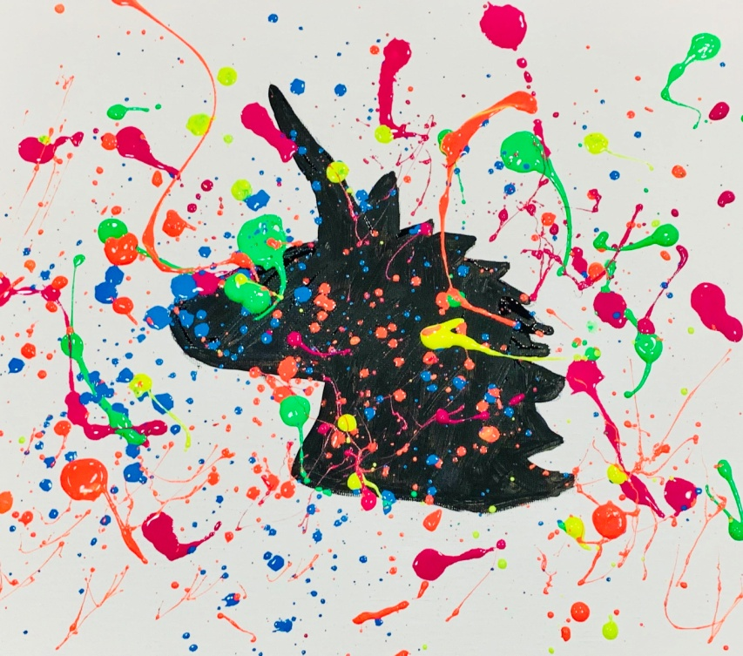
- Canvas or Heavy Paper
- Paint in your favorite colors
- Brushes (medium + thin)
- A Drop Cloth to protect your work area
- Safety glasses
- Bowls for water
- Tape
- Pencil
- Scissors

